Assignment 2
Psyc 2113
Winter 2016
Correlations & Standardized Scores
Due Monday, February 29th

This assignment is worth 10% of your final grade.

For this assignment, you will be conducting three separate correlation analyses using SPSS and R statistical software.

Rather than entering the data by hand this time, you will be able to download an SPSS data file from Desire 2 Learn for the SPSS portion of the task. For the R portion of the task you will learn how to use the read() function which allows you to read a datafile into the R Statistical Software.

Step One: SPSS Software

- Download the Assignment2.sav file from Desire 2 Learn when it becomes available. Open the file in SPSS software using the File – Open command in the menu.
- You will see that you have been giving several variables to work with. Variables will include Effort, Grade Expected, Stress, Confidence, and Favourite Colour.
- Conduct two correlation analyses. The first will be examining the association between Grade Expected and Effort. The second will be examining the association between Stress and Confidence. Make a theoretical decision to decide which variable is the predictor, and which is the outcome.
- For each separate correlation analyses, first click analyze, correlate, and bivariate in the SPSS menu. Next, select your two current variables of interest into the right-hand box on the screen. Then click “OK”.
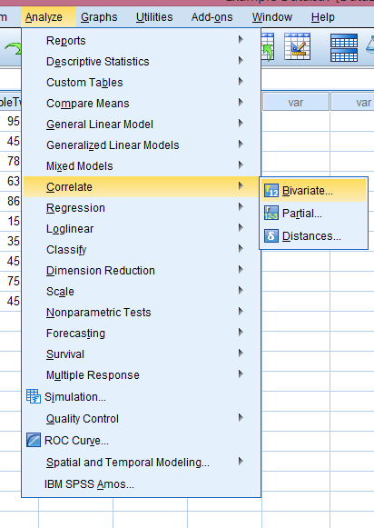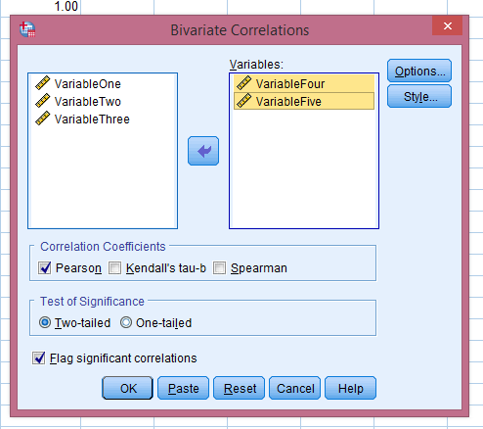

- This should create output in SPSS in the form of a table. Note the Pearon’s r (r) and the probability (p) in the outcome. In this example, the Pearson’s r is equal to -.328 or a moderate, negative correlation. The probability (p) is .355 which is a fairly likely event, indicating that the pattern of the variables is not statistically significant.

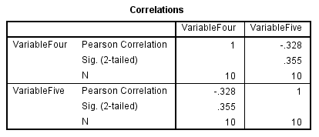

- Draw a scatterplot graph in SPSS to illustrate the correlation. To do this, click on Graphs, Legacy Dialogs, and Scatter/Dot in the SPSS menu. Then click the Simple Scatter option in the pop-up box.

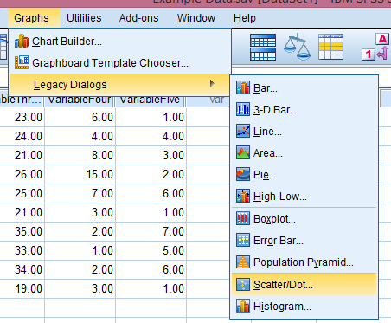
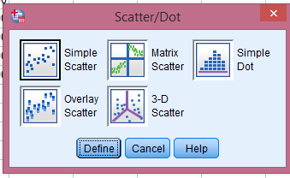
- In the Simple Scatterplot window, you need to select which variable will go on the X-axis (horizontal) and which will go on the Y axis (vertical). You should also click on the “Titles” and create a title for this chart. Once you click “Ok” the chart should appear in your output.
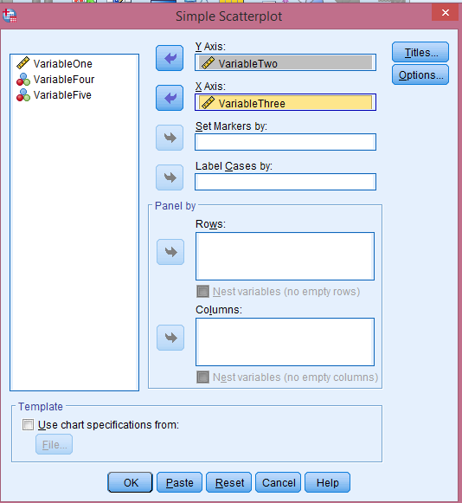
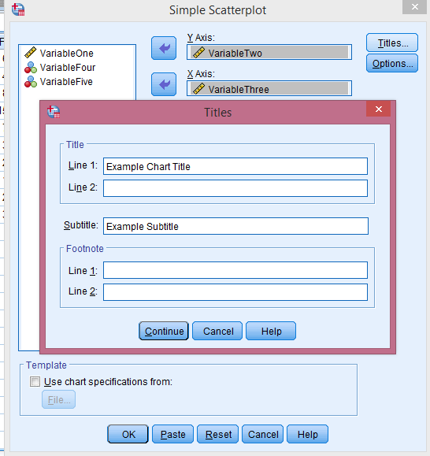

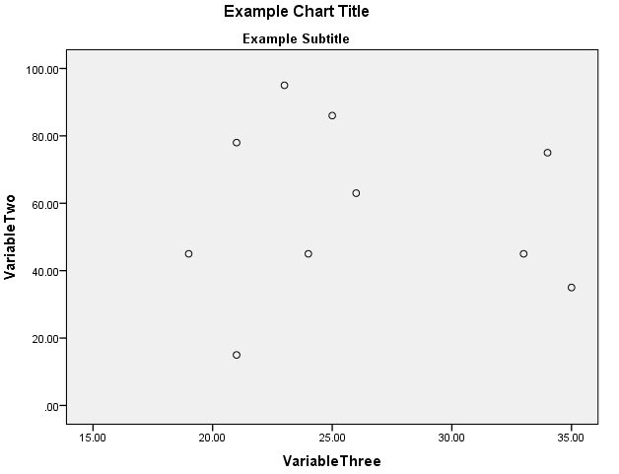
- Now you should have 2 correlation analyses and 2 scatterplots, one for Grade and Effort, and one for Stress and Confidence. To examine the correlation between Effort and Confidence you might have difficulty, as the ranges for these two variables are so different. In this case we need to standardize the scores, or convert them to z-scores.
- To convert raw scores into z-scores, click on Analyze, Descriptive Statistics, and Descriptives.
Create z-scores in SPSS
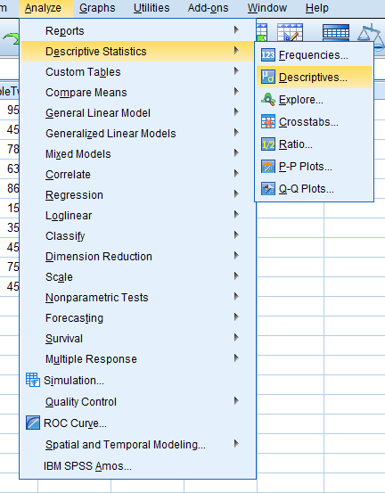
- Next, select the variables you wish to standardize, and make sure to click the square in the lower left corner to “save standardized values as variables.”
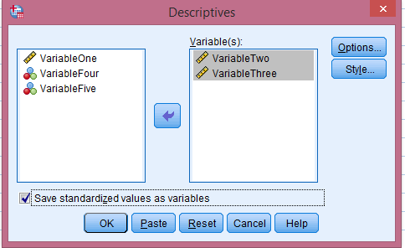
- After doing this, you should have two new variables in your dataset that are now based on z-scores. At this point, you are now able to examine the correlation between Confidence and Effort with z-scores.

Step Two: R Statistics

Now you are simply going to repeat the steps with R Statistics software. First, you must learn to read a datafile into R software. To do this, you must understand how to locate files on your computer (harddrive, flashdrive, user space, etc.).

- Download the file “Assignment2.csv” onto your computer or flashdrive.
- In R software, create a name for this dataset and use the read.csv function to locate and read your datafile. For instance, I have save the file to my computer at the follow location:

Dataset <- read.csv("C:/Users/Kathleen/Documents/Kathleen Work/Teaching/Psyc 2113/Assignment2.csv", header = TRUE, sep = ",")

- R Software is particular about a few things. Make sure to only use the / slash and not the \ when providing the location of your file. Also, make sure to use “quotes” before and after the location of your file. Use a comma after the second quote, and then include exactly as written above header=TRUE, sep=”,” this allows the R program to read the file with the proper formatting.
- If you type in the location and read command correctly, then the next time you type the name of the dataset, R should recall the full dataset. Like this:
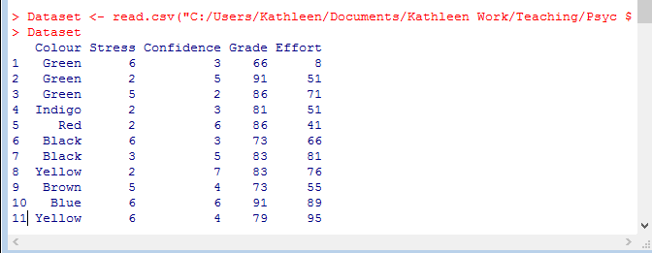
- Before you can start using this dataset in R, you need one more step. Simply use the attach() function to let R know the variables you are interested in will be in this dataset. My dataset was called Dataset, so I simply had to type:
attach(Dataset) and hit enter.
- Now you are ready to perform the first two correlations in R. To do this, you can use the cor() function. The format for this function is to state x first, then y, separated by a comma within the round brackets, then type the phrase use=”complete.obs” to drop missing cases from the dataset for that analyses.
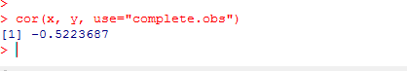
- Notice that this doesn’t give us a p value like in SPSS. There are ways to obtain a p value for correlations in R, such as through adding additional statistical libraries and functions to the package (which is beyond the scope of this assignment).
- Next, create the plot in R. To do this, simply type

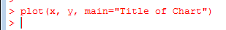
- Now, we want to create z-scores to analyze our third correlation, Confidence and Effort. To create z-scores in R, use the scale() function. To do this, create new variable called zConfidence or zEffort and define it using the scale function. See below for an example with a variable called x and a new variable called zx:
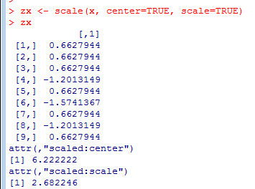
- Now complete the final correlation analysis and scatterplot using the Confidence and Effort variables. Make sure to title your graphs.

Step Three: Writing the Report

For this step, you will present three different analyses, state the variables and the rational for selecting predictors and outcomes. State the Pearson’s r and interpret, state the p value as well (obtained only in SPSS). Make conclusions about the association in terms of direction, type, and strength. Finally, show both scatterplots (from SPSS and R). Identify which correlation analysis you believe is the most meaningful on a scientific level (which has the most meaningful data).

This report should contain a total of 3 paragraphs and 6 graphs.

